INSERT LOGO  Title: Safe Work Practices & Procedure Personal Protective Equipment |  | No.
Authorized By:
Approved By:
Issue Date: | Risk Level: LOW | Page Number: 1 of 20
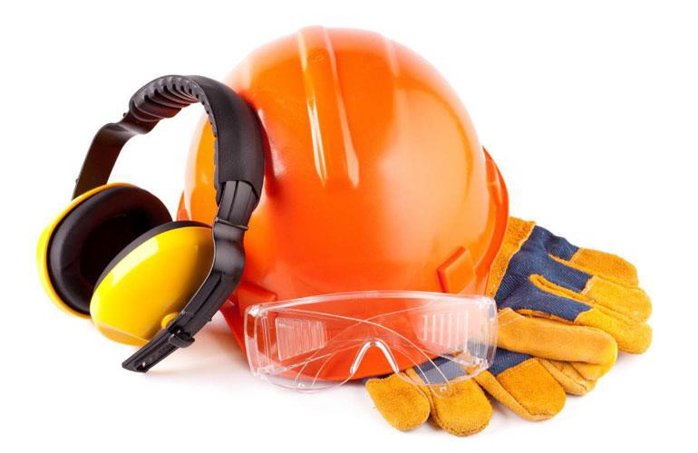DO NOT use this machine/equipment unless you have been trained in its safe use and are deemed a competent operator!
Personal protective equipment (PPE) refers to protective clothing, helmets,
Description of Work: goggles, or other garments or equipment designed to protect the wearer’s body from injury or infection.
*This information does not take precedence over Saskatchewan Employment Act and the Occupational Health & Safety Regulations.
Potential Hazards:
- Cuts & Abrasions
- Infection & Contamination
- Minor/Major Injuries
- Death
Note: Common signs and symptoms of a musculoskeletal injury (MSI) can include pain, burning, swelling, stiffness, numbness/tingling, and/or loss of movement or strength in a body part. Report these to your supervisor.
Safe Work Procedure Checklist:
1. PRE-Operation:
- Personal Protective Equipment (PPE) is a form of hazard control. It is meant to help protect employees form injury and is used to enhance the controls outlined in the “hazard control triangle” below or is employed if implementation of the other methods of hazard control are, on their own, insufficient or ineffective. Hazards should be primarily minimized by ensuring that all jobs are well planned, that workers are properly trained, and that all Safe Job Procedures are followed. PPE then provides an additional degree of protection from injury.
- All employees must be trained and are responsible for wearing the appropriate PPE for the job at hand.
- All PPE must be in good condition and worn correctly.
- All PPE must be maintained and cleaned properly.

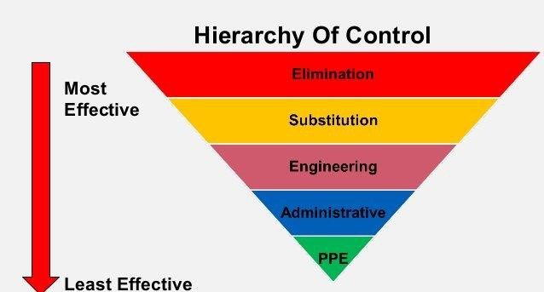

INSERT LOGO  Title: Safe Work Practices & Procedure Personal Protective Equipment |  | No.
Authorized By:
Approved By:
Issue Date: | Risk Level: LOW | Page Number: 2 of 20

- 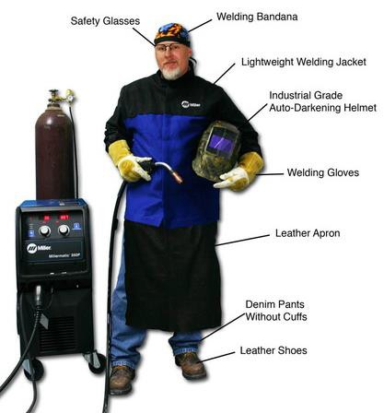Protective Clothing:
- Skin, leg and body protection will be provided if an employee is exposed to a substance or a condition that may puncture, abrade, burn, corrode, electrically shock or otherwise adversely affect the skin or be absorbed through it.
- The employee will be provided fire resistant clothing when there may be an exposure to a flash fire, molten metal, welding and burning or similar hot work hazards.
- 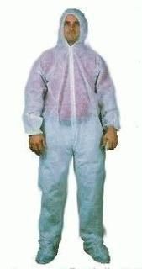Leg protective devices will be provided when the employee is required to operate a chainsaw.
- Employees must be provided with and be required to wear high visibility safety head ware and apparel when they are exposed to the hazards of moving vehicles or equipment, directing traffic on a public way or are endangered by vehicular on a public way.
- Coveralls or surgeons gown that is disposable. These gowns must be remove before the gloves and placed in a biohazard bag and autoclaved or double bagged and discarded in the regular trash.
- All workers are required to wear high visibility clothing in designated work areas.
- Welding Protective Clothing:
  - Wear 100% wool or flame retardant cotton clothing.
  - Wear long sleeved shirts with buttoned cuffs and a collar to protect the neck
  - Dark colours prevent light reflection
  - Remove shirt pockets or have flaps with buttons
  - If fall protection is required then harnesses and lanyards must be flame and spark resistant/retardant.
  - Pant legs without cuffs should cover the tops of boots. Cuffs can collect sparks
  - Repair all frayed edges, tears or holes in clothing

- 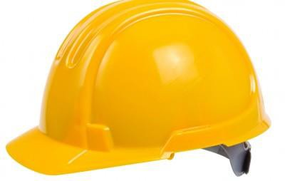Head Protection:
- Safety headwear (hardhats or helmets) is designed to protect the head from impact from falling, flying or thrown objects, bumps, splashes from chemicals or harmful substances, contact with energized objects and equipment and to make you visible in the workplace.
- Classes of headwear can include:
  - Type 1 - protection from impact and penetration at the crown (top) and
o Type 2 - protection from impact, penetration at the crown (top) and laterally (sides)

INSERT LOGO  Title: Safe Work Practices & Procedure Personal Protective Equipment |  | No.
Authorized By:
Approved By:
Issue Date: | Risk Level: LOW | Page Number: 3 of 20

- 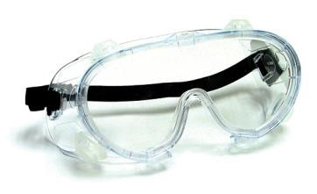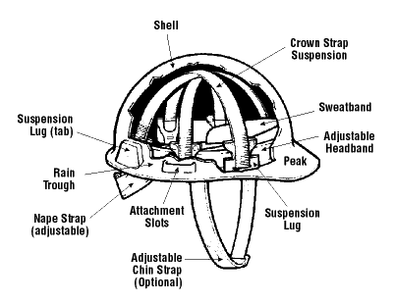Each type is also available in the following classes:

  - Class E (20 000 V electrical rating) - non-conducting material (electrical trades)
  - Class G (2200 V electrical rating) - non-conducting material (general trades)
  - Class C (no electrical rating

- Most headwear is made up of two parts:

  - The shell (light and rigid to deflect blows)
  - The suspension (to absorb and distribute the energy of the blow

- Both parts of the headwear must be compatible and maintained according to manufacturer's instructions. If attachments are used with headwear, they must be designed specifically for use with the specific headwear used.

- Employees must be provided with and be required to wear high visibility safety headwear and apparel when they are exposed to the hazards of moving vehicles or equipment, directing traffic on a public way or are endangered by vehicular traffic on a public way.

2. Eye & Face Protection:
- Eye protection must tbe worn when there is a chance of an object, particle, silver, piece of metal, gasous material, caustic or acid, or other harmful substance striking your eyes. Ther are many types of protection, just as there are many types of hazards. Safety eyewear can be found in the form of glases, goggles or face shields.
- To be CSA-approved, eye protection must offer side protection and cover the whole temple area. Markings indicate safety approval are usually found on the frame inside the temple near the hinges of the glasses. The lenses must be either plastic or polycarbonate, both of which are lightweight, but scratch easily. Plastic lenses have poor resistance to impact by sharp or pointed objects and are significantly weakened by scratches or chipped edges. They should therefore be disposed of and replaced immediately if significantly scratched. Polycarbonate lenses offer good UV protection and are more impact resistant, even if badly scratched.

INSERT LOGO  Title: Safe Work Practices & Procedure Personal Protective Equipment |  | No.
Authorized By:
Approved By:
Issue Date: | Risk Level: LOW | Page Number: 4 of 20

- Hardened glasses prescription lens and sun and sport glasses are not an acceptable substitute for proper, required industrial safety eye protection. Safety eyewear should always be worn on top of prescription lenses.
- Protection googles (chemical splash type) are to worn to prevent contact with eye tissue and tear ducts.
- Full face shields and goggles must be worn when the work at hand requires maximum eye and face protection
- See Welding PPE below for more detailed instructions
- Ensure eye protection is CSA Approved.
- Ensure your eye protection fits properly and that your vision is not impeded or distorted (close to the face). Comfort and fit are very important when selecting eye protection.
- Lens coating, venting or fittings may be needed to prevent fogging.
- Clean safety glasses regularly. Rinse them first with water to remove any large particles, then clean with soap and water and dry with a clean cloth
- If you wear contact lenses under your eye protection, always carry spare glasses and immediately remove contact lenses with washed hands if you feel any irritation form dust particles.
- How do I select proper safety glasses and face protection?

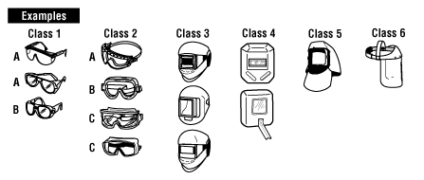
 | Nature of hazard | Hazardous Activities involving but not limited to | Recommended protectors
 | Flying Objects | Chipping, scaling, stonework, drilling, grinding, buffing, polishing, hammer mills, crushing, heavy sawing, planing, wire and strip handling, hammering, unpacking, nailing, punch press, lathwork | Class 1A - Spectacles Class 2A, 2B - Goggles Class 5A, 5B - Hoods  Class 6A, 6D - Face shields
 | Flying particles, dust, wind, etc. | Woodworking, sanding, light metal working and machining, exposure to dust and wind, resistance welding (no radiation exposure), sand, cement, aggregate handling, painting, concrete work, plastering, material batching and mixing | Class 1A - Spectacles Class 2A, 2B - Goggles Class 5A, 5B - Hoods  Class 6A, 6D - Face shields
 | Heat, sparks, and splash from molten materials | Babbiting, casting, pouring, molten metal, brazing, soldering, spot welding, stud welding, hot dipping operations | Class 1B - Spectacles Class 2C - Goggles Class 5C, 5D - Hoods  Class 6B, 6C, 6D - Face Shields
 | Acid splash, chemical burns | Acid and alkali handling, degreasing, pickling and plating operations, glass breakage, chemical spray, liquid bitumen handling | Class 2B - Goggles Class 5B - Hoods  Class 6A - Face Shields
 | Abrasive blasting materials | Sand blasting, shot blasting, shotcreting | Class 2B - Goggles  Class 5B - Non-Rigid Hoods Class 6A - Face Shields

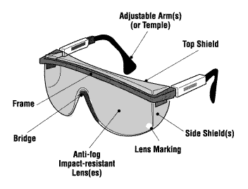
INSERT LOGO  Title: Safe Work Practices & Procedure Personal Protective Equipment |  | No.
Authorized By:
Approved By:
Issue Date: | Risk Level: LOW | Page Number: 5 of 20

 | Nature of hazard | Hazardous Activities involving but not limited to | Recommended protectors
 | Glare, stray light (where slight reduction of visible radiation is required) | Reflection, bright sun and lights, reflected welding flash, photographic copying | Class 1A - Spectacles Class 2A, 2B - Goggles Class 5A, 5B - Hoods Class 6A - Face Shields
 | Injurious optical radiation (where moderate reduction of optical radiation is required) | Torch cutting, welding, brazing, furnace work, metal pouring, spot welding, photographic copying | Class 1B - Spectacles Class 2C - Goggles Class 5C - Hoods  Class 6B - Face Shields
 | Injurious optical radiation (where large reduction of optical radiation is required) | Babbiting, casting, pouring, molten metal; brazing, soldering, spot welding, stud welding, hot-dipping operations | Class 3 - Helmet Class 4 – Hand shield
 | Laser radiation | Laser cutting, laser surgery, laser etching | Class 2D - Goggles
 | Electric arc flash | Electrical installation, electrical maintenance, troubleshooting of electrical systems, disconnecting live electrical systems | Class 2E - Goggles Class 5E - Hoods  Class 6D - Face shields
 | From: CSA Standard Z94.3.1-16 Guideline for selection, use and care of eye and face protectors, 2016

INSERT LOGO  Title: Safe Work Practices & Procedure Personal Protective Equipment |  | No.
Authorized By:
Approved By:
Issue Date: | Risk Level: LOW | Page Number: 6 of 20

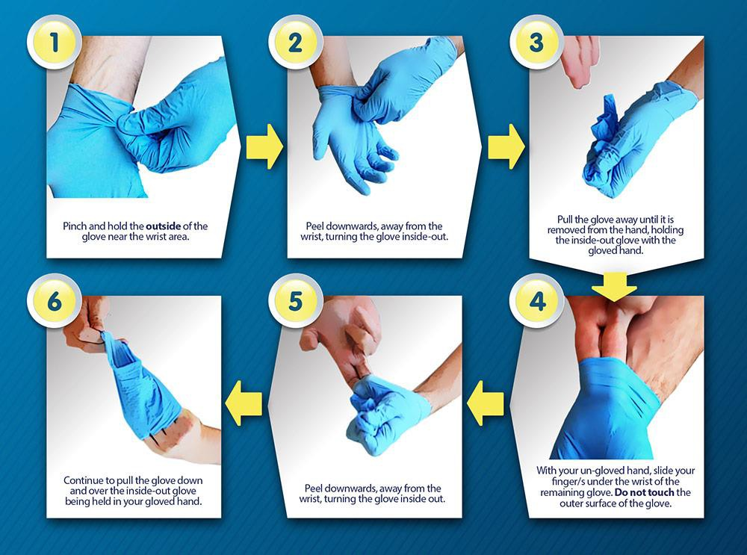
- Gloves:
  - Gloves:
    - Rubber – Thick (neoprene, latex, or butyl) for removing dead rodents from traps. Gloves should be disinfected with 5% Lysol or 10% bleach before removing and hands should be thoroughly washed with soap and water after gloves are removed.
    - Latex – 2 pairs should be worn when removing organs or obtaining blood. Gloves should be disinfected with 5% Lysol or 10% bleach before removing and hands should be thoroughly washed with soap and water after gloves are removed.

    - Leather – trapping gloves worn over latex gloves should be used to remove live animals from traps. Unless badly contaminated, gloves can be disinfected with 5% Lysol or 10% bleach and air dried for subsequent use. Treat latex gloves as above. Note that leather gloves do not provide protection from the virus, only from bites, scratches, etc.
    - Gloves should be placed in a biohazard bag and autoclaved or double bagged and discarded in the regular trash.

INSERT LOGO  Title: Safe Work Practices & Procedure Personal Protective Equipment |  | No.
Authorized By:
Approved By:
Issue Date: | Risk Level: LOW | Page Number: 7 of 20
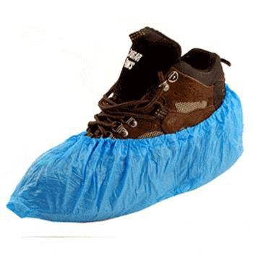

4. Foot Wear:
- Safety footwear is designed to protect against foot hazards in the workplace, and includes both hiking boots for field traversing and industrial footwear for working around heavy equipment. Safety footwear protects against compression, puncture, ankle and impact injuries. Your choice of protective footwear should always overprotect, not under protect. It is the
employee’s responsibility to know and wear the appropriate safety footwear for the environment or task.
- Rubber boots and disposable synthetic boot covers are to be used when working with contaminated materials. These covers must be remove before the gloves and placed in a biohazard bag and autoclaved or double bagged and discarded in the regular trash.
- Choose footwear according to the job hazards and approved standards.
- Lace up boot and tie laces securely (boots do not protect if they are tripping hazards or fall off)
- Use a protective boot coating to help the boot last longer and provide greater water resistance
- Choose a high –cut boot to provide ankle support.
- Selection of Safety Footwear:
o The following symbols, or markings, will help you determine which footwear is appropriate for the job.
Selection of Safety Footwear
 | Marking | Criteria | Use
 |  | Green triangle footwear has sole puncture protection with a Grade 1 protective toe (withstand impact up to 125 joules). | Any industrial or heavy work environment, including construction, where sharp objects are present (such as nails).
 |  | Yellow triangle footwear has sole puncture protection and Grade 2 protective toe (withstand impact up to 90 joules) | Light industrial work environments that need both puncture and toe protection.
 |  | White rectangle with orange Greek letter "omega" footwear has soles that provide electric shock resistance. | Any industrial environment where accidental contact with live electrical conductors can occur.  REMEMBER: Electric shock resistance is greatly reduced by wet conditions and with wear. Also know that conductive footwear as listed in CSA Z195-09 relates to an electrical discharge that might ignite volatile, flammable materials that are close to the wearer. Live electrical work should follow recommendations for an electrically conductive clothing ensemble (as specified under CAN/ULC-60895).

INSERT LOGO  Title: Safe Work Practices & Procedure Personal Protective Equipment |  | No.
Authorized By:
Approved By:
Issue Date: | Risk Level: LOW | Page Number: 8 of 20

 |  | Yellow Rectangle with green letters "SD" and grounding symbol footwear has soles that are static dissipative. | Any industrial environment where a static discharge can be a hazard for workers or equipment.
 |  | Red rectangle with black letter "C" and grounding symbol footwear has soles that are electrically conductive. | For any industrial environment where low- power electrical charges can be a hazard for workers or equipment.
 |  | White label with green fir tree symbol footwear provides protection when using chainsaws. | For forestry workers and others who work with or around hand-held chainsaws and other cutting tools.
 |  | Blue rectangle footwear provides Grade 1 protective toe with no protective sole | For industrial work that does not require puncture protection.
 |  | Grey rectangle footwear provides Grade 2 protective toe with no protective sole | For institutional and non-industrial work that does not require puncture protection.
Note 1: The ® symbol indicates the preferred position for the identifying logo or mark or the certifying agency.
Note 2: Labels are on the tongue of the right shoe at ankle height. They may also appear at ankle height on the shoe itself (for electrical protection footwear).
From: "Z195.1-09 Guideline on Selection, Care and Use of Protective Footwear," Canadian Standards Association, 2009.
An "internal protection code" is also required. This code will be permanently marked on the outside or inside of at least one shoe/boot.

Protection Code

Position: 1 2 3 4 5
Mark: 1 P M E X Position:

- level of toe protection (1 for Grade 1, 2 for Grade 2, 0 if not)
- presence of puncture-resistant sole (P if present, 0 if not)
- presence of metatarsal protection (M if present, 0 if not)
- type of electrical protection (E if shock resistant, S if static dissipative, C if conductive, 0 if no protection)
- chainsaw protection (X if present, 0 if not)

INSERT LOGO  Title: Safe Work Practices & Procedure Personal Protective Equipment |  | No.
Authorized By:
Approved By:
Issue Date: | Risk Level: LOW | Page Number: 9 of 20

- 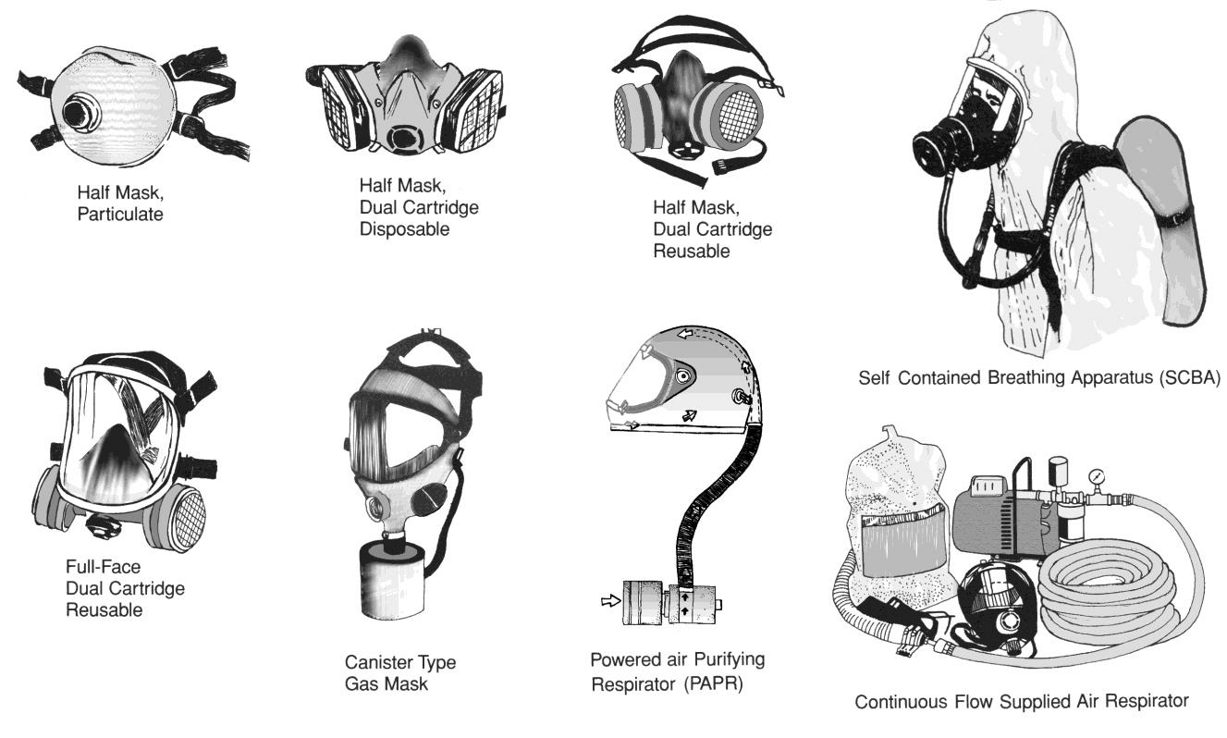Respirator:

- Selection:
  - To reduce the risk of exposure to Hantavirus, select the appropriate respirator according to this table.

Respirator Type | Use
Disposable N95 Respirator | General clean-up, handling and maintenance activities for which there is known or probable rodent contamination, but no heavy accumulations of droppings.
Half-face air-purifying respirators (APR), rubber or silicone, reusable, equipped with P100 filters | Cleaning up rodent-contaminated areas where there is an accumulation of droppings and excess dust is not being generated, or where the handling of rodents, alive or dead is uncommon.
Powered Air-Purifying respirators (PAPR) equipped with P100 filters or air-supplied respirators | Cleaning up heavy accumulation of rodent droppings where excess dust may be generated.
  - Respirators must be equipped with HEPA (high efficiency particulate aerosol) filters. Other types of cartridges are not acceptable. When breathing becomes difficult it indicates that the HEPA filter is plugged. It should be removed with gloved hands, bagged and treated as biohazardous waste.

INSERT LOGO  Title: Safe Work Practices & Procedure Personal Protective Equipment |  | No.
Authorized By:
Approved By:
Issue Date: | Risk Level: LOW | Page Number: 10 of 20

- 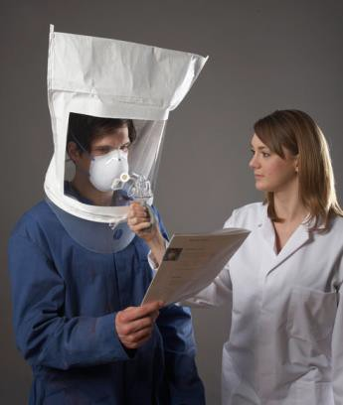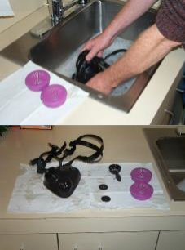Fit-Testing:
  - When a worker is first issued a respirator, they must be fit-tested with that respirator, using an accepted protocol (such as that of that in CSA standard Z94.4-02). Fit-testing ensures that the respirator fits properly and provides an effective seal with the face for the wearer.
  - Employers must maintain a record of the fit- test that includes the make, model, and size. Fit-tests must be repeated annually,
  - Each time a worker puts on a respirator, the worker must check the seal by performing a
“field check” (such as that in the CSA standard Z94.4-02). Field check is simple test performed by the wearer to ensure that the respirator is providing an effective seal with the face.
- Worker Health and Training:
  - Workers must be medically able to wear and use a respirator. Workers are to be trained in the use, care and limitations of the respirator, as follows:
    - All workers must be trained in the proper donning and doffing of their respirators.
    - Workers must check the operation of their respirators and the seal prior to each use (facial hair, eyeglasses, or other personal protective equipment must not interfere with the seal).
    - Workers must be trained to properly clean, maintain and store their respirators.
- Cleaning, Maintenance and Storage of Respirators:
  - Respirators are to be maintained and stored as follows:
    - Discard single-use respirators (N95 disposable respirators) after each use
    - Other types of respirators require cleaning and disinfecting after each use with 70% isopropyl alcohol and store in a clean plastic bag for the mask. The HEPA filter cartridges should be taped (on the face or front) with duct tape to prevent any materials collected on the filter from contaminating the storage bag or the inside of the filter. The filters should then be placed in a plastic bag if intended for re- use or into a garbage bag and taped up for discarding.
    - Inspect respirators before and after each use for signs of wear or malfunction.
    - Replace filters frequently (on respirator that have P100 filters) certainly if breathing begins to become difficult.
Store respirators in a clean, cool place, free from contamination, and in a manner that will not distort the respirator face piece.

INSERT LOGO  Title: Safe Work Practices & Procedure Personal Protective Equipment |  | No.
Authorized By:
Approved By:
Issue Date: | Risk Level: LOW | Page Number: 11 of 20

  - Confined Space Respiratory Protection:
    - Respiratory protection is one of the most common forms of PPE required in confined spaces. This should come in no surprise as the most common hazards found in confined spaces are related to atmospheric impurities and contaminants.
    - There are 4 main types of respiratory protection including:
      - Disposable Respirators
      - Air-Purifying Respirators (APR)
      - Supplied-Air Respirators (SAR)
      - Self-Contained Breathing Apparatuses (SCBA)
    - Selecting which respirator or apparatus is right for the job requires careful consideration and prior training.
    - Where respiratory equipment is required your employer must have a program in place to train workers on how to wear, use, clean, store and maintain the equipment. Do not attempt to use respiratory equipment until you have been trained on how to do so safely.
    - Disposable Respirators:
      - 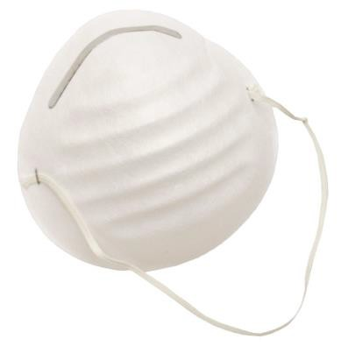Filtering face piece respirators are those respirators in which the entire face piece acts as the filter. These respirators usually cover half of your face, and are sometimes called "disposable" respirators.
      - In general, hold the respirator in your hand with the nosepiece near your fingertips. Place the mask over your nose and mouth, and hold with one hand. Using your other hand, pull the top strap over your ears. Pull the bottom strap behind your head and below your ears. If there is a clip, clip it behind your neck. If there is a
metal nosepiece, moulid it around your nose to create a proper seal.
    - Air-Purifying Respirator (APR):
      - 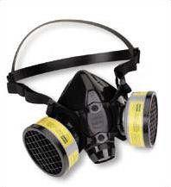Use replacement chemical cartridges that withdraw certain contaminants from the atmosphere making the air safe to breathe, the chemical cartridge you use will depend on what kind of contaminants are in the air.
      - Always make sure you use a chemical cartridge that protects you from all the contaminants in the air.
      - Only use chemical cartridges that correspond with the same brand or manufacturer of the respirator. Do not mix and match chemical cartridges and respirators form different manufacturers as they are likely not designed to be compatible with each other.
      - It is also important to note that air-purifying respirators are designed for use in atmosphere where there is a normal level of oxygen. Do not use an air-purifying respirator in a confined space that does not have enough oxygen in it.
      - Putting on a respirator:

INSERT LOGO  Title: Safe Work Practices & Procedure Personal Protective Equipment |  | No.
Authorized By:
Approved By:
Issue Date: | Risk Level: LOW | Page Number: 12 of 20

- 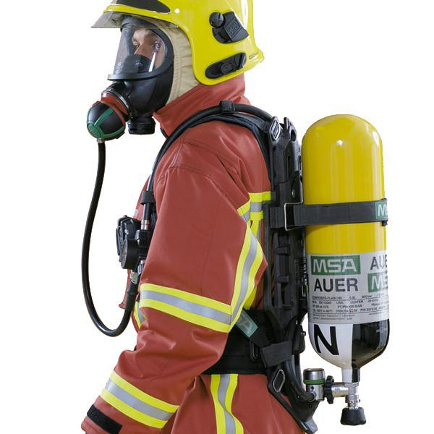Supplied-Air Respirators (SAR):
  - Provides fresh, breathable air to the worker through an airline hose or cylinder.
  - The air supply to the worker may come from outside the confined space where the air is uncontaminated or form a portable filtering system.
  - When using a supplied-air respirator makes sure the air intake area is not near the exhausted of motorized equipment or other atmospheric hazards as they may be accidently transmitted to the worker inside the confined space.
  - In the event that the air line or hose is blocked, cut-off or otherwise compromised most supplied-air respirators have a back-up device that will provide the user with a limited supply of compressed breathing air so they can exit the space.
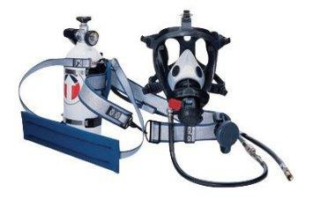
- Self-Contained Breathing Apparatuses (SCBA):
  - Is a special form of supplied-air respirators which provide breathable air to the worker form a compressed air tank, usually strapped to the workers back.
  - Self-contained breathing apparatuses are used when the oxygen levels of a confined space are too
low for worker entry and there are no other means to supply the space with breathable air.
  - Self-contained breathing apparatuses require extensive training and instruction before they can be used.
  - Remember that no matter what kind of respiratory protection you are required to use at your workplace you must be trained on how to use it safely and effectively.

INSERT LOGO  Title: Safe Work Practices & Procedure Personal Protective Equipment |  | No.
Authorized By:
Approved By:
Issue Date: | Risk Level: LOW | Page Number: 13 of 20

- 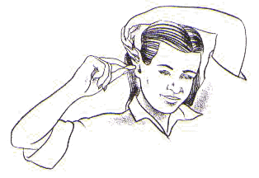Hearing Protection:
  - See Safe Work Procedure – Excessive Noise Determining Correct Hearing Protection Devices:
  - Hearing protection devices can be divided into three categories: earplugs (inserted in the external ear canal), semi-aural devices (hearing bands held against the ear canal by a headband), and earmuffs (which fit over the ears). Hearing protectors are rated according to CSA Standard Z94.2 as Class A, Class B, or Class C protection based on attenuation values as follows:

 | Maximum Equivalent Noise Level (Leq) | Recommended Hearing Protector
 | < 85 dBA | No protection required
 | 85-89 dBA | Class C
 | 89-95 dBA | Class B
 | 95-105 dBA | Class A
 | 105-110 dBA | Class A plug + Class A or Class B muff
 | >110 dBA | Class A plug + Class A or Class B muff and limited exposure

  - Few employees should have exposure levels above 95 dBA, so rarely should Class A hearing protection be required. More hearing protection is not necessarily better hearing protection because of hindrances to effective communication and general workplace sound (safety) awareness. Before selecting a particular type of hearing protector, ensure that other personal protective equipment such as eyewear, headwear, or a respirator does not interfere with the protective seal at the ear.
  - Please refer to Tool Noise Level Chart and Locations Noise Level Charts.
  - Proper Fitting of Hearing Protection Devices:
  - The amount of protection you attain depends on obtaining a good seal and even a small noise leak can substantially reduce the effectiveness of the protector.
  - Remember to check the seal several times each day. Protectors - especially ear plugs - have a tendency to work loose as a result of talking or chewing, and must be resealed occasionally.
  - Properly designed, fitted and clean ear protectors will cause no more discomfort to most workers than wearing a pair of safety glasses.
  - Earplugs are made of soft material such a neoprene to prevent injury to the ear canal. Skin irritations, injured eardrums or other adverse reactions from using ear plugs are very rare if they are kept reasonably clean.
  - There are many different styles, types and brands of ear protectors available, but when correctly fitted, they all provide similar levels of protection. The best hearing protector for you is one that fits correctly so that you can wear it properly.

Earplugs:
    - Always wash your hands before handling the ear plugs to prevent ear infections
    - Inspect ear plugs for cracks, tears, dirt and general wear and tear.
    - To insert a supple foam plug, roll the plug between your fingers and
thumb to make it thinner, making sure there are no wrinkles or folds in the plug.

INSERT LOGO  Title: Safe Work Practices & Procedure Personal Protective Equipment |  | No.
Authorized By:
Approved By:
Issue Date: | Risk Level: LOW | Page Number: 14 of 20

- 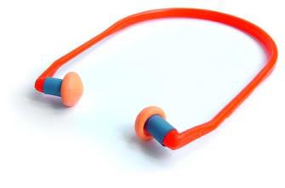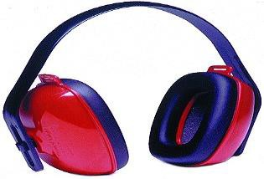Take one hand behind your head and pull your ear outward and upward to widen the auditory canal. Insert the ear plug well into the canal and hold it in place while it expands.
- NOTE: Don't be afraid to place the plug into the ear canal. You cannot hurt your eardrum because the plugs are too short to reach it. If the seal is not tight and placed too shallow, the earplug will not be effective.

Semi-Aural Devices:

- Inspect canal caps for cracks, tears, dirt and general wear and tear.
- Canal caps have flexible tips that act as caps which plug the ear canal. They differ from plugs because they DO NOT extend into the ear canal, only close the ear opening. Therefore, they do not give you as much protection as ear plugs or ear muffs.
- Canal caps are NOT designed for long term wearing, but are ideal for situations where hearing protection must be taken on and off frequently. Insert canal caps much as you would ear plugs. Reach behind your head with one hand and pull the outer ear up and back, then insert the tips of the caps into the ear, firmly pushing and wiggling them into place.
- Remember the band wraps around the back of your head.

Ear Muffs:

- Inspect ear muffs for cracks, tears, dirt, and general wear and tear
- Anything that comes between your ear and the ear muff will make them less effective thus reducing your level of protection! Hair, eyeglasses, and earrings are factors that must be considered when putting on your ear muffs.
- When choosing eyewear you may want to purchase glasses with thin temples so they don't interfere with the seal.
- Some ear muffs attach to hard hats to form a good seal when wearing a hard hat.
- Adjust the headband so the ear muffs are resting comfortably on your head. The cups should cover your entire ear.
- Welding PPE:
  - See Safe Work Procedure - Welders & Torches
  - Eye and Face Protection:
- Eye injury can occur from the intense light and radiation that a welding arc can produce. Eye injury can also occur from hot slag that the fly off from the wild during cooling, clipping or grinding.
- Wear arc welding helmets for all arc welding and darkened face shields for cutting operations. Always swear safety glasses or goggles as a second line of defence.
- Do not use gas welding goggles for arc welding.
- Wear safety glasses with side shields at all times, even under welding helmets.
- Replace pitted or cracked lenses.
- Protect eyes from flying pieces of slag when chipping the weld
- Do not substitute modified glasses, sunglasses, and smoked plastic or other materials for proper welding lenses.
- Replace loose or damaged helmets. Invisible and dangerous light rays (ultraviolet) can get in undetected.
- Contact lens user should prevent dust and particles from getting in their eyes. Foreign particles can collect behind the lens and cause severe discomfort and possibly eye damage
- Protect your eye from welding light by wearing a welder’s helmet fitted with a filter shade that is suitable for the type of welding you are doing.
- ALWAYS wear safety glasses with side shields or goggles and face shield when chipping or grinding a work piece.

INSERT LOGO  Title: Safe Work Practices & Procedure Personal Protective Equipment |  | No.
Authorized By:
Approved By:
Issue Date: | Risk Level: LOW | Page Number: 15 of 20

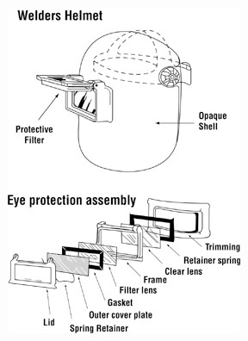
- Types of eye and face protection appropriate for welding tasks:
  - The various types of eye protection are broken down into classes in the Canadian Standards Association (CSA) standard Z94.3.1 “selection, use and care of protective eyewear”. Each class has a specific use that tit has been designed for. Common protectors for welding operations are:
    - Class 2C – direct non-ventilated goggles with radiation protection
    - Class 3 – welding helmets
    - Class 4 – Hand Shields
    - Class 5C – non-rigid helmets with radiation protection
    - Class 6B – face shields with radiation protection
    - Class 7B – respirator face piece with radiation protection
  - The following operations require full face protection from either a welding helmet or a hand shield:
    - Arc Welding
    - Plasma Arc Cutting, Gouging or Welding
    - Air Carbon Arc Cutting
  - For gas cutting, welding or brazing the intensity of the light is much less than from arc welding cutting or gouging processes. Lighter shade filter lenses can be used with googles in place of a helmet.
- Components of a welding hand shield or helmet:
  - Hand shields or helmets provide eye protection by using an assembly of components:
- Helmet Shell – must be opaque to light and resistant to impact, heat and electricity
- Outer cover plate made of polycarbonate plastic which protects from UV radiation, impact and scratches
- Filter lens made of glass contains a filler which reduces the amount of light passing through the eyes. Filters are available in different shade numbers ranging from 2 to
14. The higher the number, the darker the filter and the less light pass through the lens.
- Clear retainer lens made of plastic prevents any broken pieces of the filter lens from reaching the eye.
Gasket made of heat insulating material between the cover lens and the filter lens protects the lens form sudden heat changes which could cause it to break. In some models the heat insulation is provided by the frame mount instead of a separate gasket.
separate gasket.

- Welding Helmet Filter Shade Selection:
  - For arc welding, the correct filter shade is selected according to the welding process, wire diameter, and operating current.
  - Always use the suggested shad numbers instead of minimum shades
  - Provide additional task lighting that suits welders needs
  - Use the same shade as the welders if you are directly observing the welding arc
o For further information on shade numbers refer to CSA-W117.2
- Screens:
  - Screen electric welding operations to prevent the welding arc from affecting other workers
  - Ensure all screens are constructed of sturdy opaque or translucent materials. Permit at least 50cm (20”) bottom clearance for ventilation. Post warnings to alert other workers. Use verbal communication as well.
- Respirator:
  - Respiratory protection is needed when ventilation is not sufficient to remove welding fumes or when there is risk of oxygen deficiency. Select and use respirators in compliance with CSA standards.
The process of selecting appropriate respiratory protection is outlined in CSA standard Z944.4.
INSERT LOGO  Title: Safe Work Practices & Procedure Personal Protective Equipment |  | No.
Authorized By:
Approved By:
Issue Date: | Risk Level: LOW | Page Number: 16 of 20

Selection of Shade Numbers
Welding Operations | Shade Number Suggested | Welding Operations | Shade Number Suggested
Torch Soldering | 2 | Shielded Metal Arc Welding:
Torch Brazing | 3 or 4 | 2.5 to 4 mm (3/32 to 5/32”) Electrodes | 10
Oxygen Cutting |  | 4 to 6.4 mm (5/32 to ¼”) Electrodes | 12
-Under 25 mm (1”) | 3 or 4 | Over 6.4 mm (1/4”) Electrodes | 14
-25 to 150 mm (1” to 6”) | 4 or 5 | Gas Tungsten-Arc Welding
-Over 150 mm (6”) | 6 or 8 | Under 50A | 10
Gas Welding |  | 50 to 150A | 12
-under 3.2mm (1/8”) | 4 or 5 | 150A to 500A | 14
-3.2 to 12.7 mm (1/8 to  ½”) | 5 or 6 | Gas Metal-Arc Welding
Over 12.7 mm (1/2”) | 6 or 8 | 60 to 160A | 10
Carbon-Arc Welding | 14 | 160-250A | 12
 |  | 250-500A | 14

INSERT LOGO  Title: Safe Work Practices & Procedure Personal Protective Equipment |  | No.
Authorized By:
Approved By:
Issue Date: | Risk Level: LOW | Page Number: 17 of 20

- 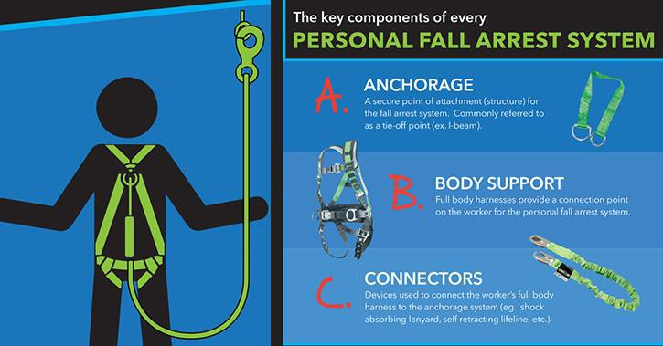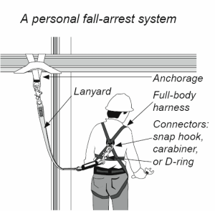Fall Protection
  - See Safe Work Procedure – Fall Protection Types of Fall Protection:
- 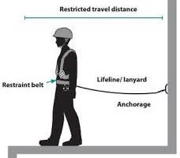Travel Restraint – Prevents workers from getting too close to a fall hazard by use of a tie-off system (harness, lanyard tied off at a set length from a weighted tie-off point)

  - Fall Arrest – Protects workers by stopping or arresting them in mid-fall from a working surface (includes harness, anchorage support, lifeline, and/or lanyard).
Personal Fall Protection System:
- The key word in the PFPS (Personal Fall Protection
System) acronym is “SYSTEM”. The PFPS is a system of three (3) singular items working together to keep the worker safe. A PFPS shall consist of A B C:
The key components of every
PERSONAL FALL PROTECTION SYSTEM

- Anchor Points - All temporary and permanent anchor points shall be approved prior to use. Effective anchor points rely on effective consideration of:
  - Types of anchors;
  - Strength (capacity) of anchors;
  - Compatibility of connection; and
- Location of the anchor

INSERT LOGO  Title: Safe Work Practices & Procedure Personal Protective Equipment |  | No.
Authorized By:
Approved By:
Issue Date: | Risk Level: LOW | Page Number: 18 of 20

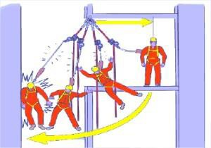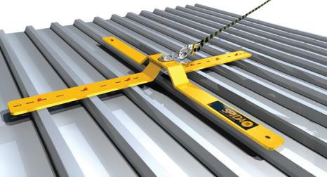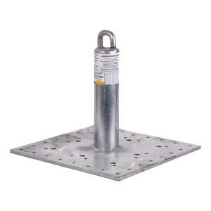Types of Anchors

Temporary Anchor
A temporary anchor shall be installed in locations where a worker would perform work for a short duration that would not benefit from the installation of a permanent anchor (i.e., Beam clamps, beam strap and wire rope).

Permanent Anchor
Permanent anchors shall be:
  - Approved by a professional engineer;
  - Clearly identified as permanent anchors; and
  - Installed in a location where a worker would regularly perform work (providing the worker could not be protected by other means, including task redesign, guardrails etc.).
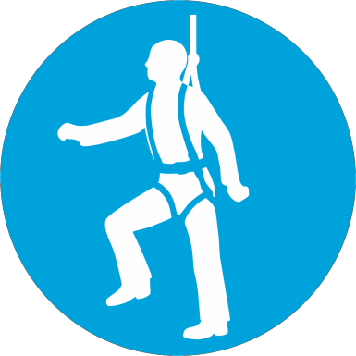Permanent travel restraint systems must be permanently marked as being for travel restraint only.

Strength (Capacity) of Anchor Points
Strength requirements for anchor points are listed below:

PFPS Force
Temporary Travel Restraint 800 lbs
Permanent Travel Restraint 2000 lbs
Fall Arrest 5,000 lbs

Compatibility of Connection
The size and shape of the anchor must be compatible with the snap hook or carabineer that attaches to it. Always consult the manufacturer’s instructions to confirm compatibility.

PFAS anchor shall be positioned to:

Location of PFAS Anchor

- Minimize the free fall distance to a maximum of 1.2 meters
- Minimize the "pendulum" or "swing" fall effect
- Be easily accessible from a safe location
- Facilitate effective rescue.

- Body Support – A worker must wear a full body harness when using a personal Fall Protection System. A full body harness or a restraint belt when using a Personal Travel Restraint System. Both the full body harness and restraint belt must be CSA approved and comply with Sask OH&S Regulations.

INSERT LOGO  Title: Safe Work Practices & Procedure Personal Protective Equipment |  | No.
Authorized By:
Approved By:
Issue Date: | Risk Level: LOW | Page Number: 19 of 20

Full Body Harness
Restraint Belt

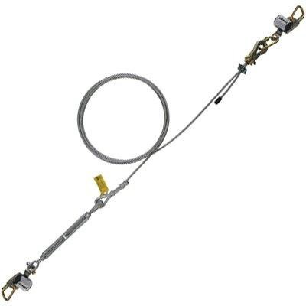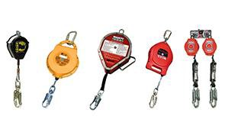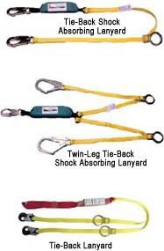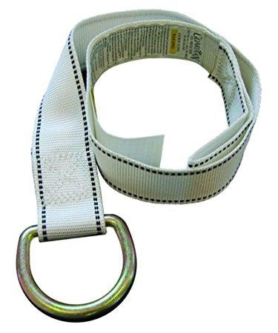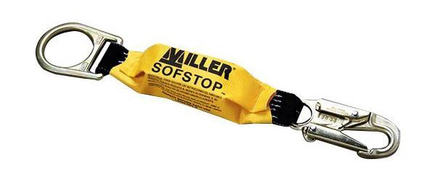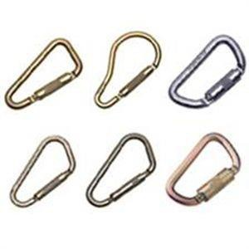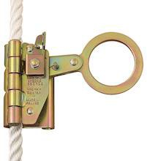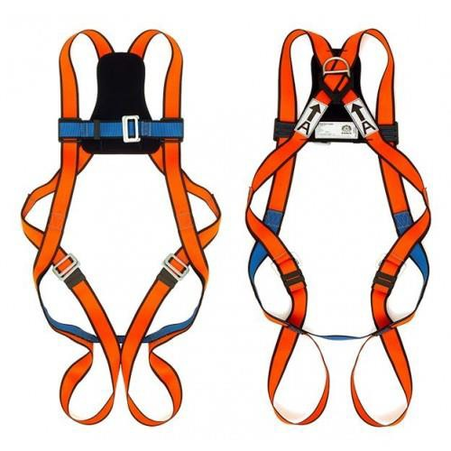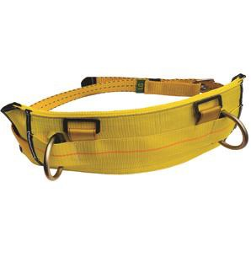A. Connecting Devices – All connecting devices must be CSA approved and comply with Sask OH&S Regulations. Consult the manufactures instructions for correct use of each device. Some connecting devices are:

Energy or Shock Absorber

Lanyards (shock absorbing is preferred)

Carabineers

D Rings

Lifeline

Rope Grabbing Device
Self-Retracting Lines

INSERT LOGO  Title: Safe Work Practices & Procedure Personal Protective Equipment |  | No.
Authorized By:
Approved By:
Issue Date: | Risk Level: LOW | Page Number: 20 of 20

9. Maintenance:
- All PPE will be inspected by the employee at the time of issue and before each use.
- All PPE that is of questionable reliability, damage or in need of service or repair will be removed from service, tagged “Out of Service”, reported to your supervisor and will not be returned to service until tagged “Service or Repaired” by a qualified person.
- All PPE shall be stored and maintained according to manufacturer’s instructions
- No time of PPE may be modified or used contrary to its manufacturer’s instructions or specifications or applicable legislation or regulations.
10. Cleaning:
- All PPE is considered contaminated after use and must be either disinfected and air dried or washed with hot water, bleach (powdered bleach if clothing is not colour fast ) and detergent, then dried in a hot dryer (may also be air dried in the sun). If no laundry facilities are readily available, clothing should be immersed in liquid disinfectant until they can be washed. When laundering clothing, use gloves to place the items into the washing machine.
- Wash gloved hands in a disinfectant then remove gloves and wash hands in soap and water. If that is not possible then the clothing should be placed in a bucket of disinfectant If articles are to be discarded, they should be soaked with disinfectant and double bagged for proper disposal later (autoclave bag or regular Trash).
Decontamination Procedure for PPE:
- After any activity involving the handling of contaminated or potentially contaminated material and before leaving the immediate work area, apply these procedures. Do not remove respiratory protective equipment until other decontamination steps are complete.
  - Remove coveralls and boot covers at the perimeter of the work area, and place them in a disposable bag. Collapse the bag and temporarily seal it.
  - Move away from the clean-up or contaminated area to a location where there are no other workers (preferably outdoors) leaving eye and respiratory protection in place.
  - Wet-wipe exposed reusable respirator surfaces, eyewear and rubber footwear with a disinfection solution.
  - Rinse the outside of gloves in the disinfectant solution. Remove the gloves and place them in a plastic bag for disposal (or if the gloves are reusable, disinfect them before storing them).
  - Place disposable respirator in a plastic bag. Permanently seal the bag. Seal the bag. For reusable respirators, tape shut the inlet opening of the respirator cartridges to prevent the release of dust (cartridges may be reused until breathing becomes difficult) or discard the cartridges. Clean and disinfect the respirator body. Store the respirator in a cool, clean location free form contamination.
  - Remove eyewear. Clean and disinfect it before storing it, or discard it.
  - Wash exposed skin surfaces thoroughly with soap and water.
Forms Associated with this Policy
- INSERT APPLICABLE OHS LEGISLATION HERE IF REQUIRED

