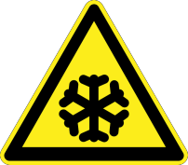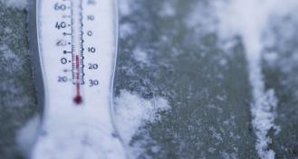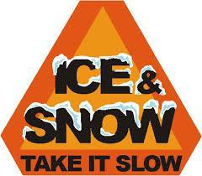
INSERT LOGO  Title: Safe Work Practices & Procedure Natural Hazards- Winter Hazards |  | No.
Authorized By:
Approved By:
Issue Date: | Risk Level: MED | Page Number: 1 of 7

Description of Work: |  | Outdoor workers are exposed to many types of hazards that depend on their type of work, geographic region, season, and duration of time they are outside. Employers should train outdoor workers about their workplace hazards, including hazard identification and recommendations for preventing and controlling their exposures.
*This information does not take precedence over Saskatchewan Employment Act and the Occupational Health & Safety Regulations.
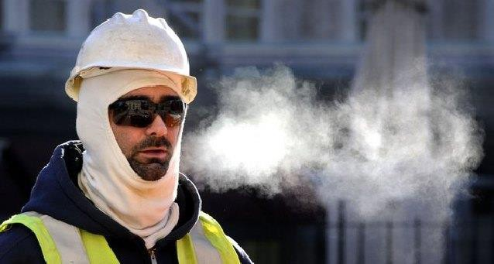 |  |  |  |  | Potential Hazards:  - Cold Stress  - Hypothermia  - Frostbite  - Trench Foot  - Chilblains
*This Safe Work Procedure covers most hazards found in nature, but not all. For more hazards and more in- depth information contact Centre for Disease Control and Prevention (https://www.cdc.gov/).
Personal Protective Equipment (PPE) Required (Check the box for required PPE):
Gloves | Face Masks |  | Eye Protection | Welding Mask |  | Appropriate Footwear | Hearing Protection | Protective Clothing
Other PPE: As required by surrounding area wear all required PPE (face mask, gloves, ear protection, and weather appropriate clothing). Always wear appropriate footwear and high visibility clothing while working alone or around machinery.
Safe Work Procedure Checklist:
1. Winter Hazards:
- Cold Stress:
  - Cold Temperatures:
    - Workers who are exposed to extreme cold or work in cold environments may be at risk of cold stress. Extremely cold or wet weather is a dangerous situation that can cause occupational illness and injuries such as hypothermia, frostbite, trench foot, and chilblains.
    - The body can tolerate very little exposure to cold without protective clothing. When exposure to cold temperatures, the body begins to lose heat faster than it is produces. The body cannot adjust itself as well to cold as to heat. Blood vessels will shrink in order to prevent heat loss. Workers in certain outdoor environments are especially susceptible to cold stress.

INSERT LOGO  Title: Safe Work Practices & Procedure Natural Hazards- Winter Hazards |  | No.
Authorized By:
Approved By:
Issue Date: | Risk Level: MED | Page Number: 2 of 7

- 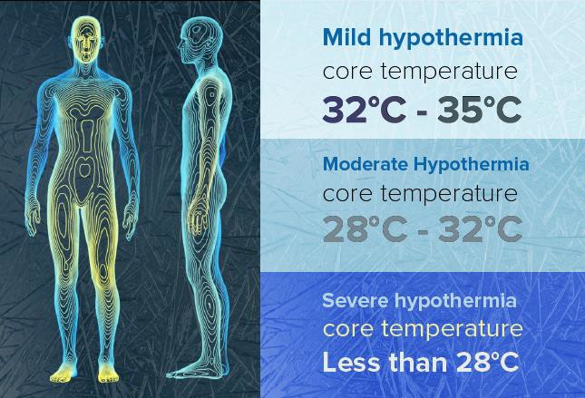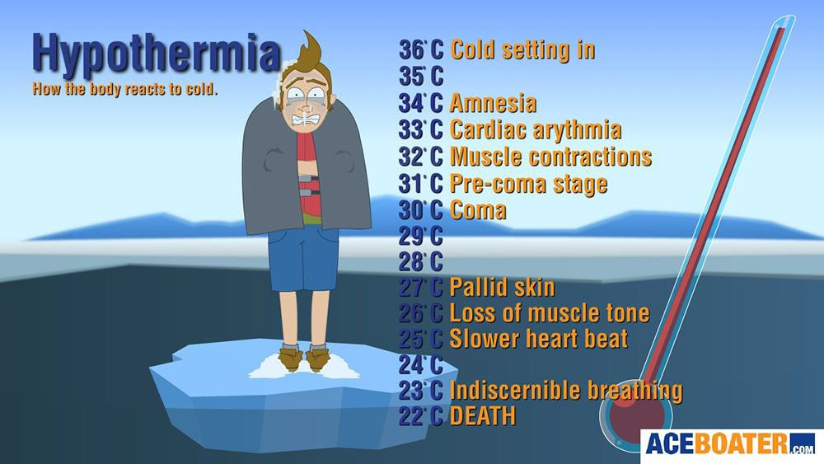Hypothermia:
  - When exposed to cold temperatures, your body begins to lose heat faster than it can be produced. Prolonged exposure to cold will eventually use up your body’s stored energy. The result is
hypothermia, or abnormally low body temperatures. This makes hypothermia particularly dangerous because a person may not know it is happening and will not be able to do anything about it.
  - Occurs when the internal body temperature drops to or below 95°F (35°C). Normal muscular and brain functions are impaired.
  - Hypothermia usually happens at very
cold temperatures, but can also occur in cooler temperatures, if an individual is submersed in water or becomes chilled from the rain.
  - Symptoms:
    - Shivering (uncontrolled) at first and then will stop
    - Fumbling hands or clumsy movements
    - Slurred speech
    - Memory loss/confusion
    - Erratic behaviour
    - Fatigue
    - Blue/purple skin colour
    - Dilated pupils
    - Slowed pulse and breathing
    - Unconsciousness

INSERT LOGO  Title: Safe Work Practices & Procedure Natural Hazards- Winter Hazards |  | No.
Authorized By:
Approved By:
Issue Date: | Risk Level: MED | Page Number: 3 of 7

  - 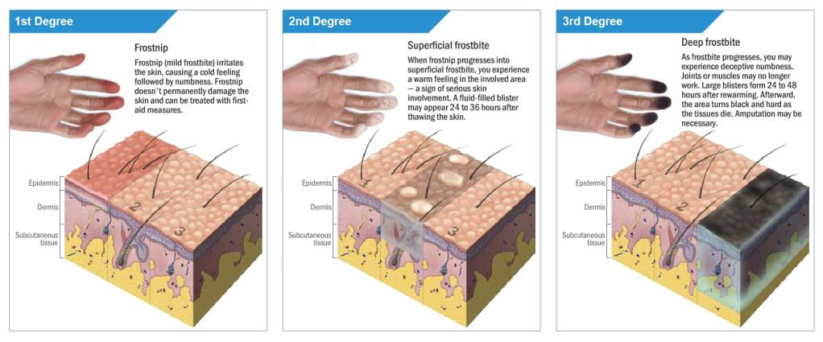First Aid:
    - Request immediate medical assistance by calling 911.
    - Move the victim into a warm room or shelter
    - Remove wet clothing
    - Warm the centre of their body first – chest, neck, head, and groin – using an electric blanket or dry layers of blankets, clothing, or towels.
    - In conscious, warm beverages may help increase the body temperature. Do not give alcohol
    - Once temperature has increased keep them dry and wrapped in a warm blanket, including the head and neck.

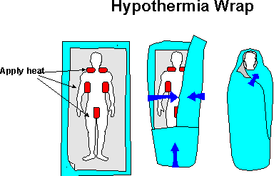
- Frostbite:
  - Frostbite is an injury to the body that is caused by freezing. Frostbite causes a loss of feeling and colour in the affected area. If most often affects the nose, ears, checks, chin, fingers and toes. In extremely cold temperatures, the risk of frostbite is increased in workers with reduced blood circulation and among workers who are not dressed properly.
  - This is the actual freezing of tissue. Exposed skin is susceptible to frostbite when the air temperature is below 0°F (-17°C) or when there are high winds combined with cold temperatures. Frostbite can lead to tissue damage, scarring and possible amputations.

INSERT LOGO  Title: Safe Work Practices & Procedure Natural Hazards- Winter Hazards |  | No.
Authorized By:
Approved By:
Issue Date: | Risk Level: MED | Page Number: 4 of 7

  - Symptoms:
    - Reduced blood flow to hands and feet
    - Numbness
    - Aching
    - Tingling or stinging
    - Bluish or pale, waxy skin that is cool to the touch
  - First Aid:
    - Get to a warm room as soon as possible.
    - Unless necessary, do not walk on frostbitten feet or toes.
    - Immerse the affected area in warm (not hot) water or warm the affected area using body heat. Do not sue a heating pad, fireplace, or radiator for warming.
    - Do not massage the frostbitten area; doing so may cause more damage.
    - If severe seek medical treatment.

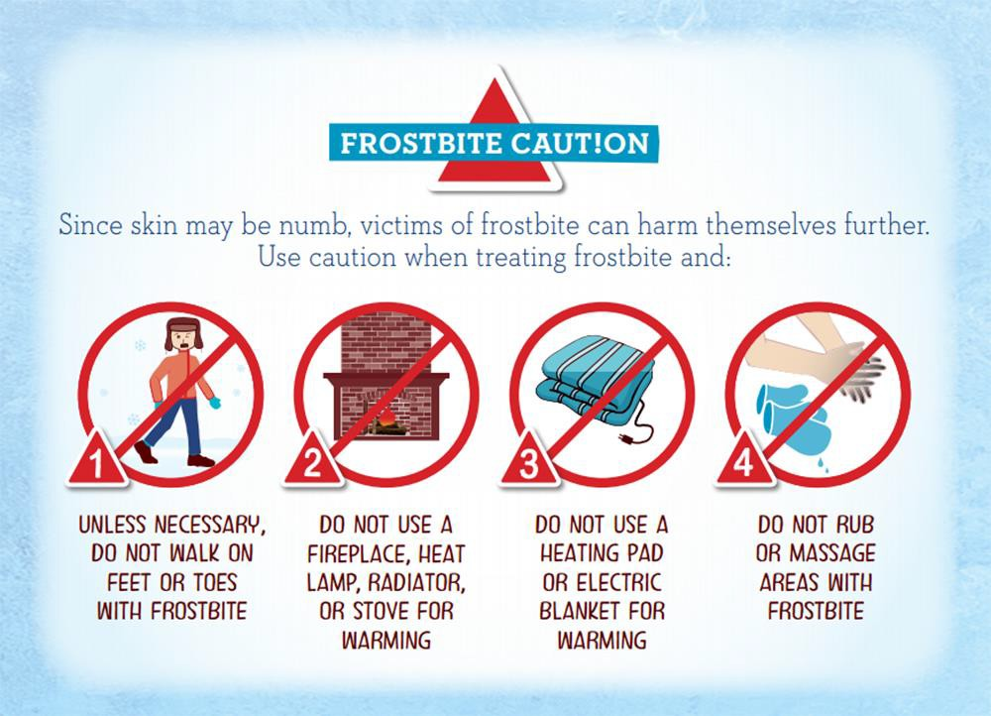
- Trench Foot:
  - You can get trench foot when your feet are wet and cold for too long. Moisture causes your feet to lose heat and this can slow the blood flow and damage tissue. Trench foot can happen when it is as warm as 60°F (16°C).
  - Trench Foot, also known as immersion foot, occurs because wet feet loose heat 25- times faster than dry feet. Therefore, to prevent heat loss, the body constricts blood vessels to shut down circulation in the feet. Skin tissue begins to die because of lack of oxygen and nutrients and due to the build-up of toxic products.
  - There is no formation of ice crystals in the tissues and usually develops slowly over a period of hours or days.

INSERT LOGO  Title: Safe Work Practices & Procedure Natural Hazards- Winter Hazards |  | No.
Authorized By:
Approved By:
Issue Date: | Risk Level: MED | Page Number: 5 of 7

  - Symptoms:
    - Initially reddened skin, which later becomes pale and swollen
    - Numbness, followed by leg cramps
    - Blister formation, followed by ulceration
    - Tingling pain
    - Bleeding under the skin
    - Gangrene (foot may turn dark purple, blue or grey)
  - First Aid:
    - Remove shoes/boots and wet socks
    - Dry feet thoroughly
    - Avoid walking on feet, as this may cause tissue damage.
    - If severe seek medical treatment.
- Chilblains:
  - Ulcers formed by damaged small blood vessels in the skin, caused by the repeated exposure of skin to temperatures just above freezing to as high as 60°F (16°C).
  - This damage is permanent and the redness and itching will return with additional exposure. The redness and itching typically occurs on checks, ears, fingers and toes.

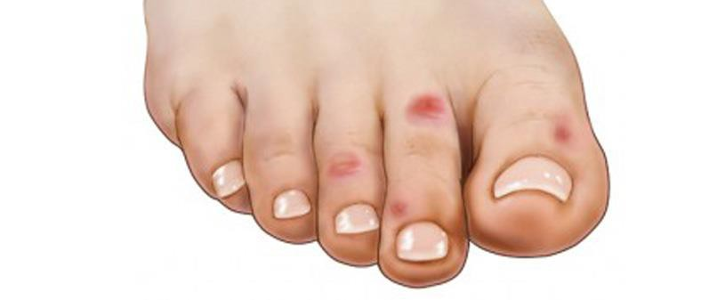
  - Symptoms:
    - Redness
    - Itching
    - Possible blistering
    - Inflammation
    - Possible ulceration in severe cases.
  - First Aid:
    - Avoid scratching
    - Slowly warm the skin
    - Use corticosteroid creams to relieve itching and swelling.
    - Keep blisters and ulcers clean and covered.

INSERT LOGO  Title: Safe Work Practices & Procedure Natural Hazards- Winter Hazards |  | No.
Authorized By:
Approved By:
Issue Date: | Risk Level: MED | Page Number: 6 of 7

- 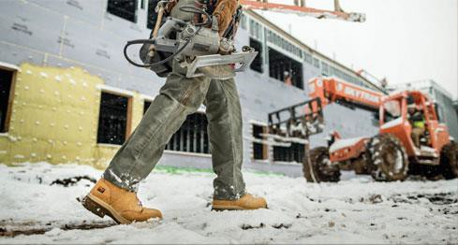Prevention:
  - When you must work in the cold, always be prepared and be aware.
  - Remember prolonged exposures to cold temperatures could cause you to make poor decisions or react more slowly than normal. Tell your supervisor if you are not dressed warmly enough.
  - Pay attention to warning signs and symptoms of hypothermia, frostbite, and other cold-related illness and injuries. When the first signs are present take necessary precautions.
  - Advise your supervisor of any pre-existing conditions that could affect your ability to work in cold temperatures.
  - Do the majority of the work in the warmest part of the day.
  - Be aware of changing weather conditions and plan your work accordingly.
  - Take frequent breaks in shielded areas or in heated shelter.
  - Drink warm, non-caffeinated beverages and water. Eat high calorie meals to maintain body temperature.
  - In extreme cold work in pairs or use a buddy system so that you can monitor one another for the effects of hypothermia and frostbite.
  - Use thermal insulation on equipment handles when temperatures call below 30°F (0°C).
  - Carry extra socks, gloves, hats and jackets along with blankets and a change of clothes to keep dry. Remember to keep your feet dry!
  - Be aware that some clothing may restrict movement resulting in a hazardous situation. Some clothing may restrict full range of vision and you should be aware of this limitation so you can adjust your work habits.
  - Include chemical hot packs in your first aid kits.
  - Do not allow you to overheat and sweat excessively.
  - Do not allow evaporated liquids (alcohols, gasoline, or other liquids with very low freezing temperatures ) to come into contact with bare skin
  - Do not remain indoors for long periods of time while wearing outdoor clothing.
  - Avoid working in extreme cold while fatigued and exhaustion, as greater energy is required to stay warm.

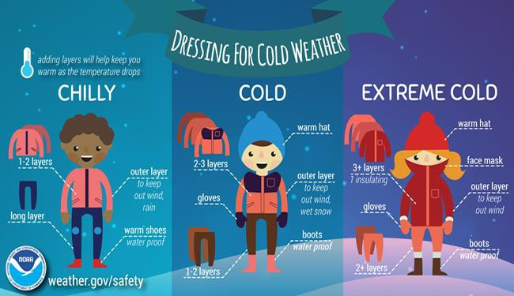
INSERT LOGO  Title: Safe Work Practices & Procedure Natural Hazards- Winter Hazards |  | No.
Authorized By:
Approved By:
Issue Date: | Risk Level: MED | Page Number: 7 of 7

- PPE
  - Wear several layers of loose clothing, it is recommended to have at least 3 layers. Tight clothing reduces blood circulation to the extremities. Layering provides better insulation. The Layers should be:
    - An outer layer to break the wind (gortex or nylon)
    - A middle layer of down or wool to absorb sweat and retain insulation
    - Inner layers of synthetic weave to allow ventilation.
  - 40% of body heat can be lost through the head so wear an insulated hat or hardhat liner.
  - Gloves and shoes should be waterproof and insulated.
  - Protect ears, face, hands and feet in extremely cold or wet weather.

Forms Associated with this Policy
- INSERT APPLICABLE OHS LEGISLATION HERE IF REQUIRED

