INSERT LOGO  Title: Safe Work Practices & Procedure Computer Workstation |  | No.
Approved By:
Authorized By:
Issue Date: | Risk Level: MED | Page Number: 1 of 3
DO NOT use this machine/equipment unless you have been trained in its safe use and are deemed a competent operator!
Description of Work: |  | The computer desk and related ergonomic desk are furniture pieces designed to comfortably and aesthetically provide a working surface and house or conceal office equipment including computers, peripherals and cabling for office and home-office users.
*This information does not take precedence over Saskatchewan Employment Act and the Occupational Health & Safety Regulations.
Potential Hazards:
- Awkward / sustained postures – prolonged sitting
- Repetitive movements – typing, using mouse

Note: Common signs and symptoms of a musculoskeletal injury (MSI) can include pain, burning, swelling, stiffness, numbness/tingling, and/or loss of movement or strength in a body part. Report these to your supervisor.
Personal Protective Equipment (PPE) Required (Check the box for required PPE):
Gloves | Face Masks |  | Eye Protection | Welding Mask |  | Appropriate Footwear | Hearing Protection | Protective Clothing
Other PPE Suggestions:
- Adjustable monitor arms are helpful to move monitor into various positions
- Articulating keyboard trays can be adjusted so that wrists are in a neutral (straight) position. Typing with bent wrists puts pressure on the tissues in the carpal tunnel
Safe Work Procedure Checklist:
1. PRE-Operation:
- Sitting for long periods with poor body positions can place more stress on your body. This can affect you from your wrists to your shoulders and low back up to your neck. This stress will often build up over time and can lead to symptoms such as eye strain, back soreness / stiffness, or headaches.
- Take steps to avoid. Before working at a workstation, adjust the chair and other equipment.
- Workstation Set-Up:
  - Computer monitors
    - Positioned directly in front of the worker – particularly if it is viewed frequently or constantly.
    - The top of the screen should be at the worker’s eye level.
      - Bifocal or Trifocal wearers will normally have better success if the screen is slightly lower – 5 to 10 cm. Below eye level.
    - The screen should be 45 to 60 cm from the worker’s eyes.

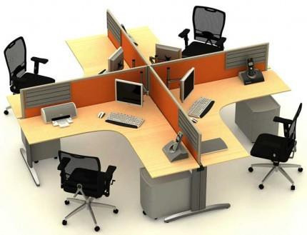

INSERT LOGO  Title: Safe Work Practices & Procedure Computer Workstation |  | No.
Approved By:
Authorized By:
Issue Date: | Risk Level: MED | Page Number: 2 of 3

- 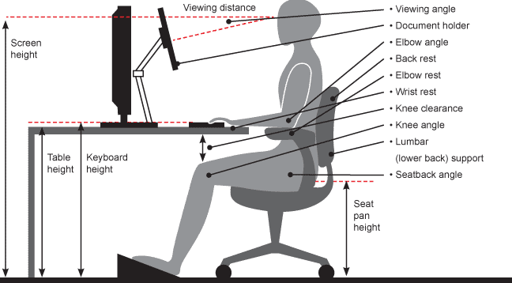Keyboard:
  - To position the keyboard at the optimum height, the worker should be able to sit upright with the arms hanging naturally from the shoulders. The elbows should bend at approximately 90 degrees when the fingers are on the home row of the keyboard.
- Mouse:
  - Should be as close to the user’s side as possible (little stretching).
  - The worker’s arm and hand should in the natural position as discussed for keyboard use.
  - The size and shape of the mouse should also be considered.
    - the wrist should be bent as little as possible
    - the buttons should not require awkward finger positions or stretching
    - It is best if the mouse is moved from the shoulder, rather than just having the wrist and fingers provide the movement.
- Seating:
  - Should be height-adjustable so that the workers can positions his/her body at the optimum height for proper monitor, keyboard and mouse positioning.
  - The worker should be able to vary seating position through the day
  - The seat height should allow the worker to place his/her feet flat on the floor with the thighs roughly parallel to the floor.
  - If the monitor height is not adjustable, the seat height should be adjusted.
    - Footrests should be used by shorter workers to allow the seat height to be raised to the optimum height.
  - Try to sit with good posture as much as possible.
- Desks:
  - Where desk height is adjustable workers are most able to ensure ergonomic positioning.
  - Newly-purchased office furniture should offer the most in flexibility.
- Additional equipment might be appropriate. Workers should request these if they require them:
  - Headsets for those using the telephone a lot.
  - Document holders (which should be placed beside the screen and at the same level).
  - Anti-glare screens

•

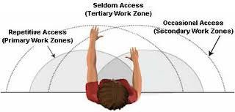
INSERT LOGO  Title: Safe Work Practices & Procedure Computer Workstation |  | No.
Approved By:
Authorized By:
Issue Date: | Risk Level: MED | Page Number: 3 of 3

- Workstation Organization:
  - Organize your work materials and accessories into primary and secondary work zones

4. Look away from your screen periodically to refocus your eyes. A good practice is the 20-20-20 guideline which is to look away from your computer screen every 20 minutes and look at something 20 feet away for 20 seconds
5. Avoid prolonged sitting. Periodically get up and move around.
- Follow these general office safety guidelines:
  - Keep stairs, aisles, walkways and floors clear of obstructions and clutter.
  - Close drawers of desks and filing cabinets when not in use.
  - Replace or report defective office furniture, office equipment or appliances to management.
  - Review and follow the manufacturer’s directions with respect to the use of all office equipment, appliances and furniture.
  - Know the location of fire extinguishers for the office area
  - Know the emergency response procedures applicable to the office areas.
Forms Associated with this Policy
- INSERT APPLICABLE OHS LEGISLATION HERE IF REQUIRED

